Author View
Getting started
Invitation
As a new Author in the Causeway eAuthoring you will receive and invitation to create a set of credentials that will enable you to access the system
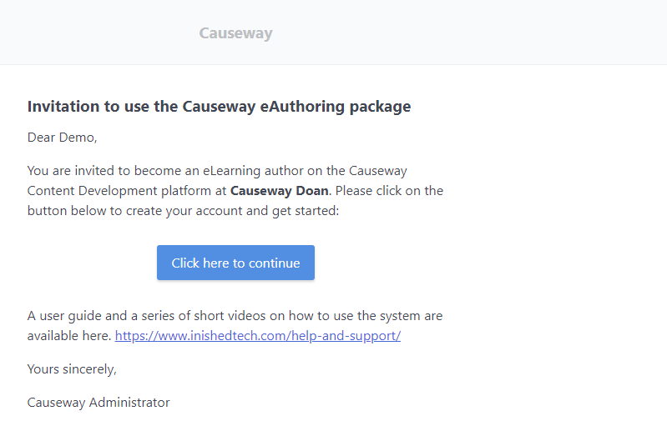
Click on the [Click here to continue] button
The following screen appears
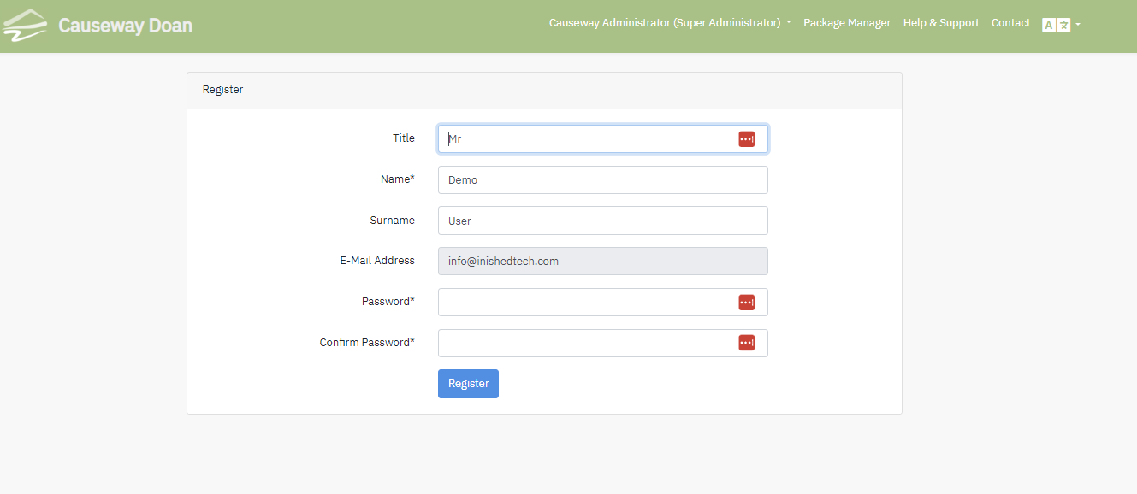

Confirm your name and input the password you want to use. Click on the Register button. You will then see the Package Manager Screen within Causeway.
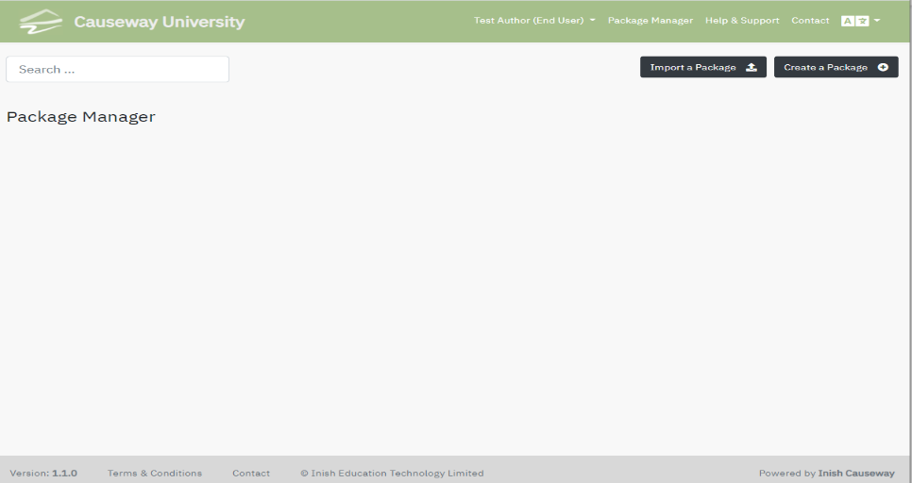
Using the URL provided to access the Causeway eAuthoring system, the following screen appears. Use your email address as a credential and input the password you created when you received the invitation to access the system. Having filled in the fields click on the Login button.
- Log into the system
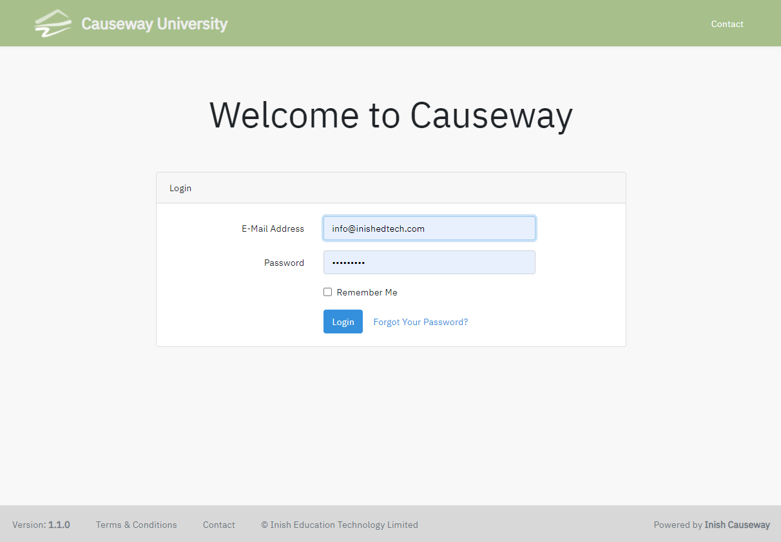

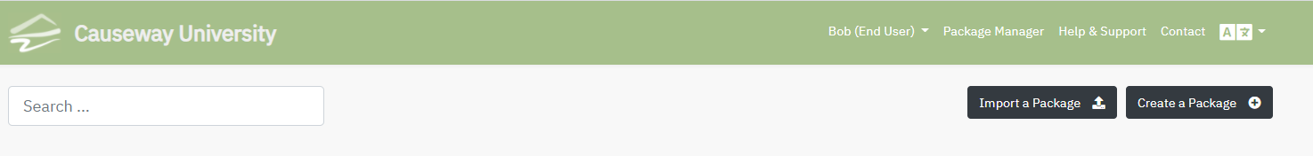
The system opens on the Package Manager screen, initially this screen will have no packages. The Opening Banner Menu has a number of buttons

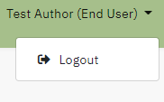
User Name:-
Clicking on this exits the system
This displays your name, the down arrow to the right gives access to the logout button.
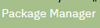
Package Manager
This takes you to the list of packages that are available in your account
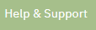
Help & Support
This takes the author to support web page where useful tips and instructions can be found.

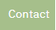
Contact
You can use this screen to ask the Support staff any specific queries you may have.
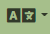
Language selection
The icon enables the Author to select the language used for the Causeway system commands. There are 5 languages available , English, French, Netherlands, Suomi & Swedish. These can be selected as desired. Other languages are available.

The line beneath this top bar has 3 buttons
Search | Used to locate a package when you have multiple files within Causeway
Import a Package | Used to import a package that has been exported from Causeway in SCORM format  An author can also import a PowerPoint slide pack into Causeway. Using this option each slide is imported as an image element. The Causeway package editor can then be used to add additional elements to make a richer learning object than a simple slide show. For example an audio tract can be added to the slides using the new audio feature. If the PowerPoint slide pack has an existing sound track then this automatically uploaded with the slides.
Create a Package | Using this button enables an Author to create a package from scratch using the Edit package screen

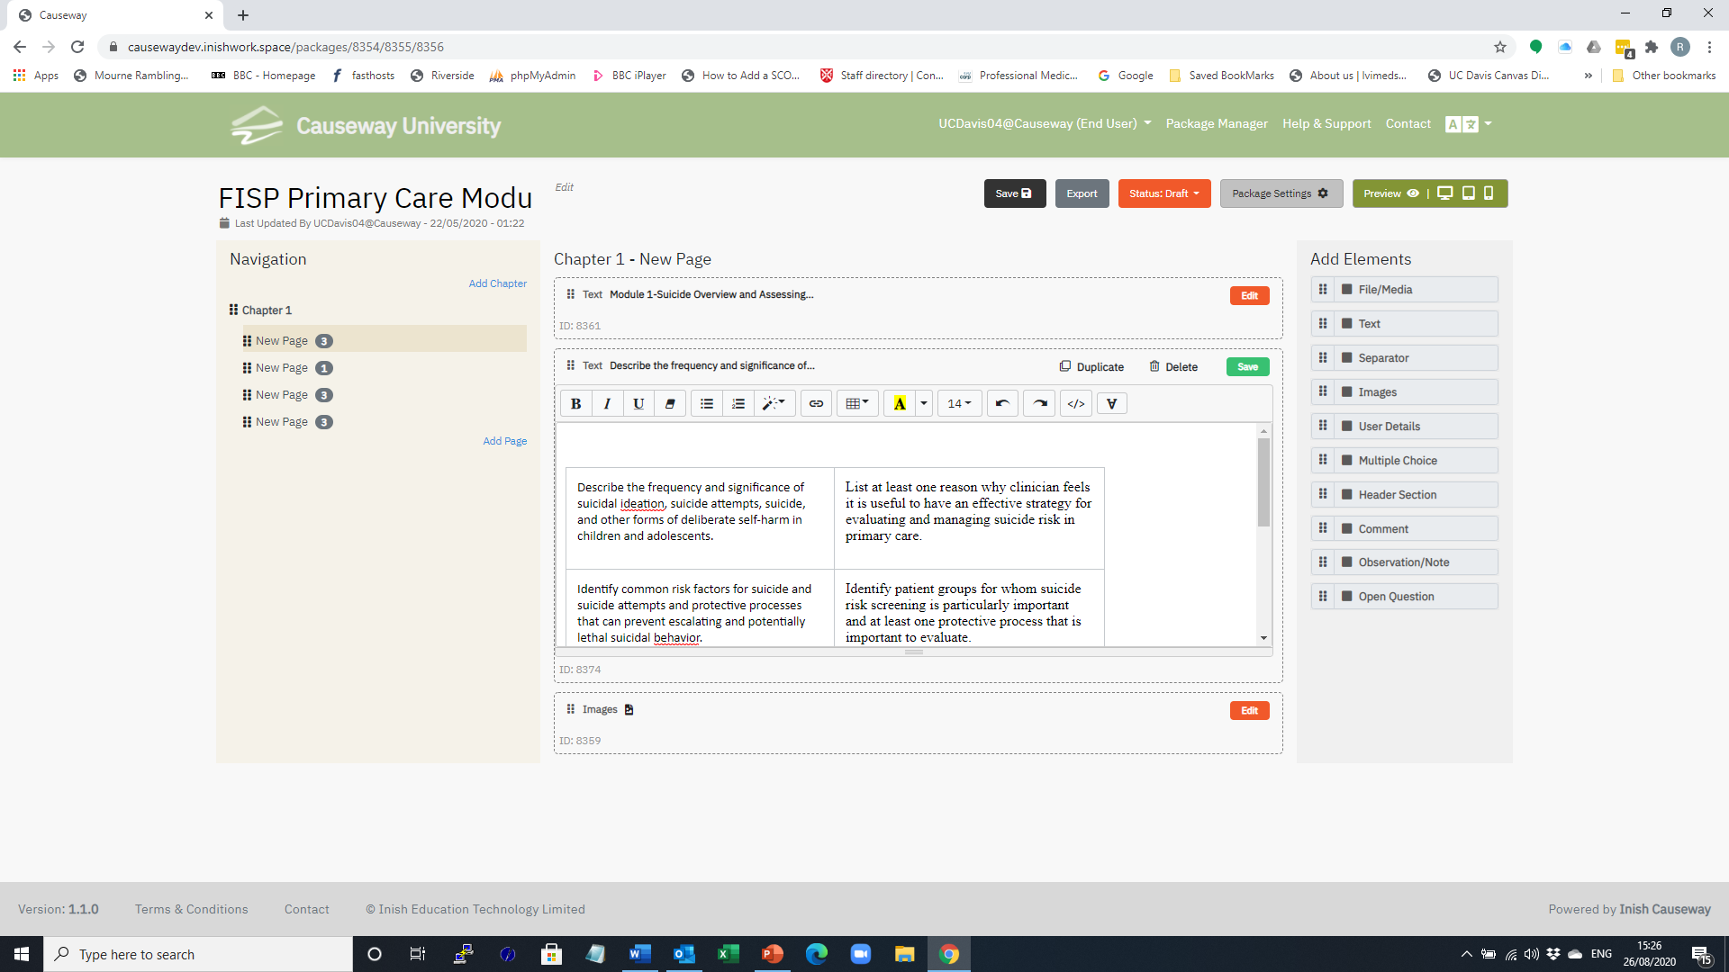
Edit Page - Screen Layout
Elements
Edit Panel
Navigation Panel
Package Title
Menu Options

Package Title | The title of the package currently being edited.
Menu Options | Save –This saves all changes to the package
Navigation Panel | This displays the structure of the package you are authoring and is built up as you add new chapters and pages. The order of these chapters can be changed by dragging a page or chapter using the symbol to a new position and pressing Save.
Edit Panel | This displays the page that corresponds with the place holder highlighted in the navigation panel. When elements have been added to the page, the order they are displayed in can be altered by moving the elements on the page using the  Symbol and pressing Save.
Elements | Elements are the components that can be added to the Edit Panel. By placing the cursor on the symbol. These components can be dragged into the panel.  Within the Edit panel the element order can be changed by dragging the elements up and down the screen. Press Save to store these changes

A sample screen.
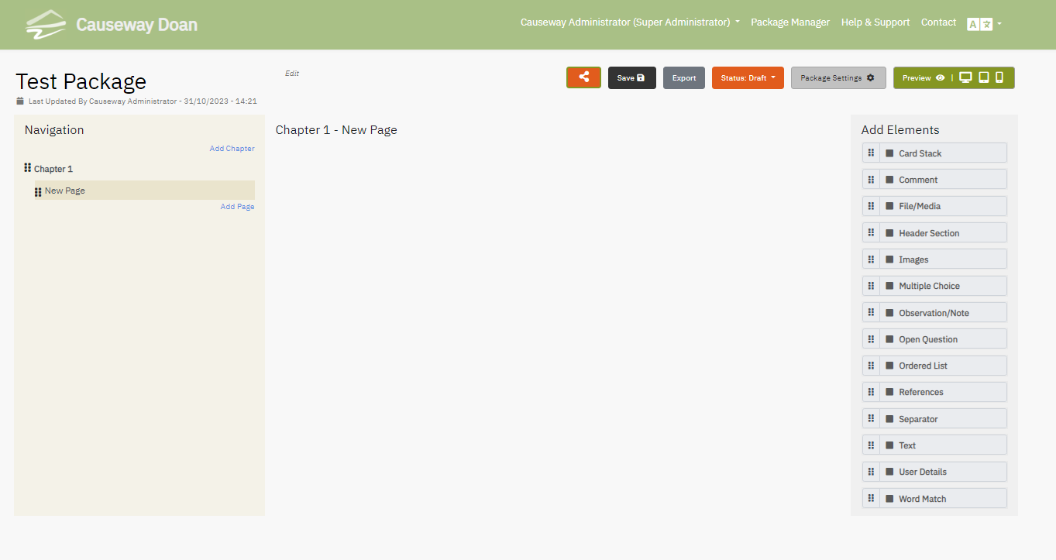

As you add elements to the Edit Panel you can preview (see below) what your package will look like to learners. Always remember to Save your work as you progress.

Element | As you complete each element press Save to store your work.
Card Stack | This element allows the author to create a set of flash cards. The cards may contain images and/or text.
Comment | The Comment element can be added when the Author wants to add additional information to the Package. The text block is tagged with Comment label in the published package.
File/Media | This element allows the uploading of video or audio clips which can be played by the student. If the file is any other format it is stored, and the student can download the file to their PC. When Click to Upload is invoked the File Management system on your PC is launched to enable the selection of the desired file. If the file is in PDF format then the learner can view the content on their screen without downloading.
Header Section | The Header Section element enables the input of text content and several tools are available to enable the formatting of the Header
Images | This element is used to import an image to the package using the PC’s file manager. This image is scaled to fit the page on the learner’s device. It is possible to add up to four images which can be displayed in a line. A caption can be added for each image, this can be placed above or below the image. The author can set a flag that enables the learner to use a magnifier to view the image in close detail.
Multiple Choice | The Multiple-Choice element is very flexible and enables data to be collected about a Learner’s performance. It allows the Author to provide feedback when a correct or incorrect answer is given.  There is a flag which can be set to invite the learner to retry if they get an incorrect answer and it is possible to have more than one correct answer. If the collect learner data flag is set in Package Settings, then the Learner responses can be stored and downloaded for later analysis. If the Package is uploaded to a Learner Management system such as Canvas or Moodle, then the Learner’s performance is automatically added to the LMS’s Grade Book.
Observation /Note | The Observation / Note element can be added when the Author wants to add additional information to the Package. The text block is tagged with Observation / Note label in the published package.
Open Question | The Open Question element enables the Author to pose a question and the package will invite the Learner to type a full response. If desired the Author can provide expanded feedback in the box provided. If the collect learner data flag is set in Package Settings then the Learner response can be stored and downloaded for later analysis.
Ordered List | This element allows the author to construct an ordered list of statements. When the learner accesses this element the order is scrambled and the learner is invited to sort the list into the correct order
References | This element enables the author to build a simple order list of references. This can include URLs to external reference documents
Separator | This element places a separator bar in the body of the eLearning Package the author can specify the width of the line and the colour. If the Hide Following Elements box is ticked, then when a learner is using the package, they have to click a box to view remaining content on that page.
Text | The text element enables the input of text content and several tools are available to format this and in addition there are insert tools which enable the inclusion of URLs to external web sites, external video clips such as those hosted in Youtube or Vimeo and small images.
User Details | The User Details element can be inserted by the package Author and can be used to collect identification details of the Learners using the package. This would normally be positioned at the start of the package and is used in conjunction with the collect learner data flag in Package Settings. This element is useful to identify an answer script that has been generated using the Generate PDF option in Package settings or to print a learners name on a completion certificate.
Word Match | This element enables the author to set a short open question or to create a list answer. Having set the question, the author creates a list of acceptable learner responses. This is normally a list of acceptable synonyms for the correct answer. Sets of answers can be provided by the author and one mark is added for each line.  Experience has taught that by providing a complete answer in Feedback the author can use this to populate the acceptable answer fields.

Audio Track
It is now possible to record an audio description for any of the Causeway elements. The following icon 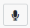 is located in the bottom right hand corner. When this is clicked the following appears on the screen.
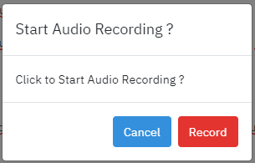
When you press Record; the recording toolbar 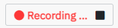 will record your input until you press the black button to stop the recording. When this happens the following appears 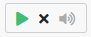, the green triangle will play back whatever you have recorded. If you are unhappy with the content the X will delete the audio track and you can re-record if you wish.
When a learner encounters an element with an added audio tracked the  icon appears in the top right hand corner of the element. When the students clicks on this icon. the following appears
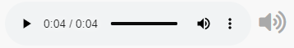 and the audio is played when the triangle is clicked.
An author can test these features with the preview options before the package is published or exported.

Menu Options
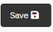
Save
This saves all activity to the data
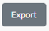
Export
As an Author you can export your package in 1 of 3 zip file formats.
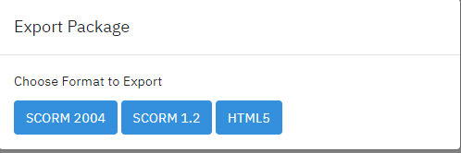

SCORM 2004 - exports the package to be loaded into an LMS such as Canvas
SCORM 1.2 - exports the package to be loaded into an LMS such as Moodle
HTML5 - exports the package which can then be loaded onto a web server where the code can be unzipped.

Status
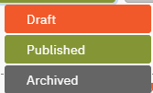

This displays the status of the Learning Package. To change the status of a package click on option required.
Draft | The Learning Package is still under development.
Published | Package has been generated as a web site which can be viewed by a number of routes    Click on the link icon in the published button  Clicking on the Show button on the Package Manager page  Clicking on Package Settings button and clicking on the Published Package URL.  The URL can copied and shared via Email, Txt or utilised on a Web site.  .
Archived? | This is set when a development for the package has stopped and a new version has been created

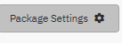
Package Settings There are 4 settings Tabs.

[General]
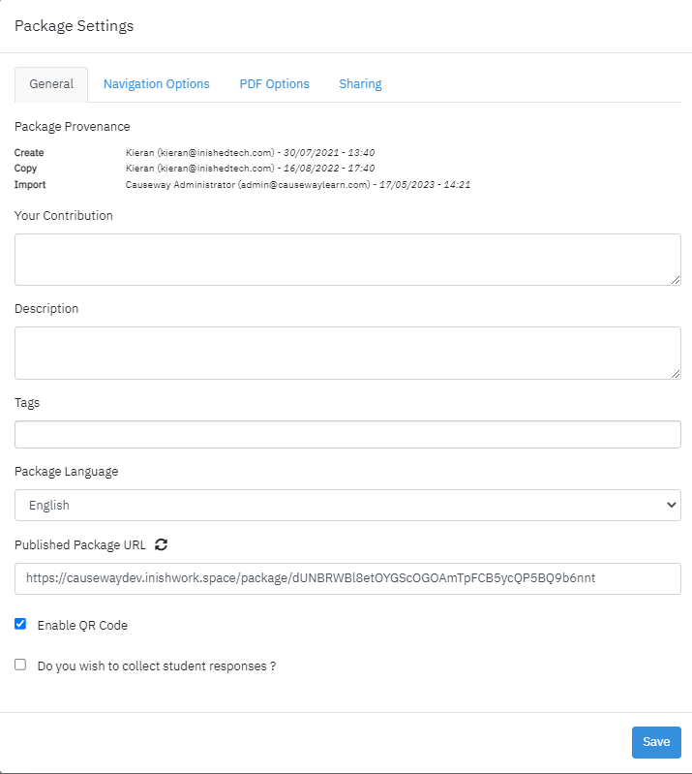
The Author can provide a description of the Learning Package in Package Settings. This can be very valuable when a Package is published and the text forms part of the meta data which accompanies the learning content.
The Author can insert Tags (Key Words) which are used in the search box when looking for a package on the Package Manager page
The Package Language drop down enables the Author to specify the Language used for the system instructions on the Published / Exported package.
The Published Package URL box contains the URL of the Learning Package
When a Package has been published and the URL distributed to Learners if this check box is ticked then Learner responses are stored on the Causeway server and the Author can download these responses as an excel spreadsheet to their local PC.
This will enable the generation of a QR code on request
Once this Settings have been set, they should be saved

[Navigation Settings]
Navigation Options:
These options can be set individually or in combination
- Hide navigation panel from learner
- Deactivate unvisited page links in learner navigation:- This enables an author to set the navigation panel so that I learner cannot jump forward in the lesson.
- Hide navigation section by default:- Learner can display the menu by clicking on the icon
- collapse chapter navigation:- In a large learning package there may be multiple pages within a chapter, by setting this flag the author causes the navigation panel to collapse to chapter headings . When the learner accesses the package, the chapters will expand to show the pages contained within.
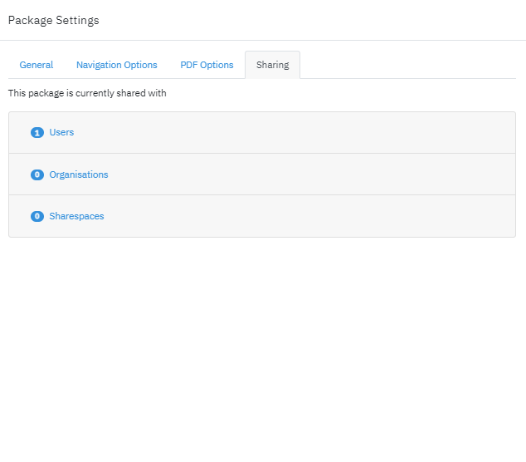



[PDF Options]
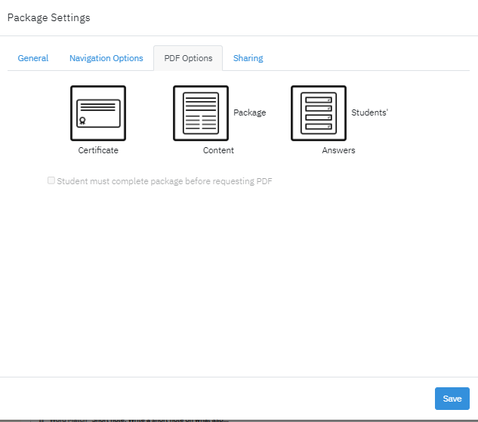
The Author can set whether a Learner can print a PDF after they have completed the published / exported Learning Package
The options are:-
Certificate – Confirming completion of the Package This can include the Learners name if the User Details element is included. And their score if the have answered any MCQs included in the package
Package Content – This included all content including images contained within the Package
Student Answers – This contains all the answers provided by the Learner to both MCQs and open questions
One, none or any of these options can be toggled on or off by the Author.
Once this Options have been set these should be saved

[Sharing]
This option is also available via the
Icon on the Edit Package page.
Users:- This option enables the author to share Causeway packages with individual colleagues.
Organisations:- With groups of colleagues within their Institution.
Sharespaces:- With public share spaces accessible by Causeway users.
The numbers inside the circles indicate the number of times the package has been shared with other Causeway authors.
Packages shared with an Author can be accessed by clicking on

the My Packages Tab on the Package Manager Screen and
selecting which shared packages they want to access.
Packages Shared with the Author can be previewed or copied to their own folder
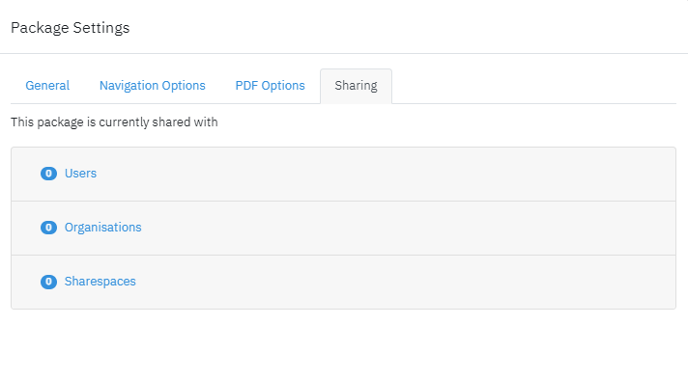

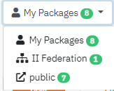

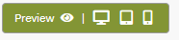
Preview
At any stage you can preview what your package will look like to your users, click on the selected icon,



The preview options available simulates what the package would look like if it were published to a
PC Tablet Smart Phone
Select the to return to the edit view.

