Administrator View
Getting Started
Introduction
As a site administrator for your institution it is your role to create the organisational structure within the Causeway eLearning system which will enable authors to create eLearning content.
The mechanism is entirely flexible, and you can create the hierarchy as simple or as complex as you require.
i.e. within your institution you might want to create a structure of several schools and within each school a number of departments. Alternatively, you might want to set up a series of subject areas.. Your users are subsequently added to your organisational structure.
When you login to Causeway. The main screen displays a top line comprised of the following tabs ‘your name’ Package Manager, Help & Support and Contact.
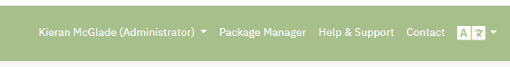
By clicking on ‘your name’ a drop-down list of options is displayed:
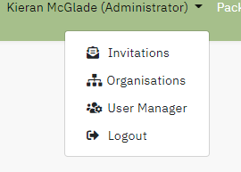
Organisation Structure

The first task is to configure your organisational structure. Click on Organisations in the drop-down list, this will display the name of your institution and a button to create a new organisational unit.
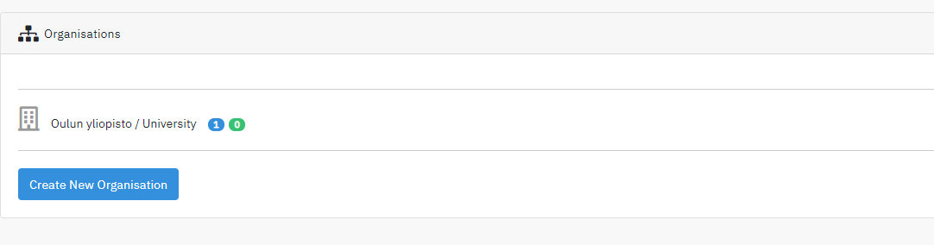
Input the name you have chosen e.g. School of Medicine, in the first field and select the parent organisation. At this stage it will only be your Institution, as the structure builds you will be able to select where in your structure you want the unit located.

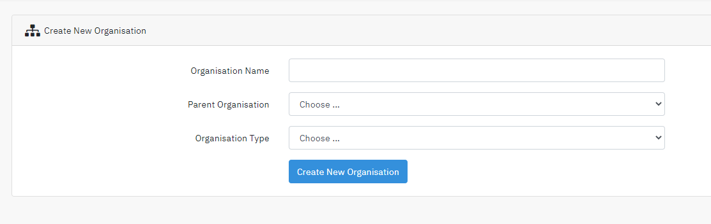
Finally select the type of type of organisation from the list provided.

Click create new organisation to save your new unit.

The list of created organisations is displayed. Repeat the above steps to create your desired structure
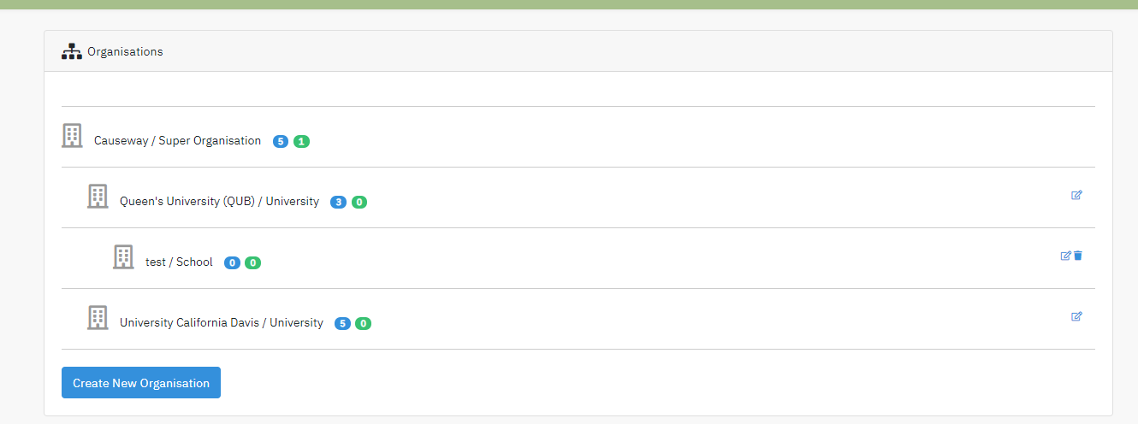
The numbers displayed beside each organisational unit indicate
In blue:- the number of authors allocated to the unit
In green:- the number of invitations sent to potential authors

The two icons to the right enable you, as an administrator, to edit the organisational unit details or delete the unit entirely from the structure. Note: the unit cannot be deleted if authors are attached to it or when invitations have been sent but not yet completed.

Also note: - it is not possible to delete the primary organisation unit in your structure.

Invitations

To invite a new author, click on Invitations

A list of the outstanding invitations to authors is displayed, these have not been accepted yet.
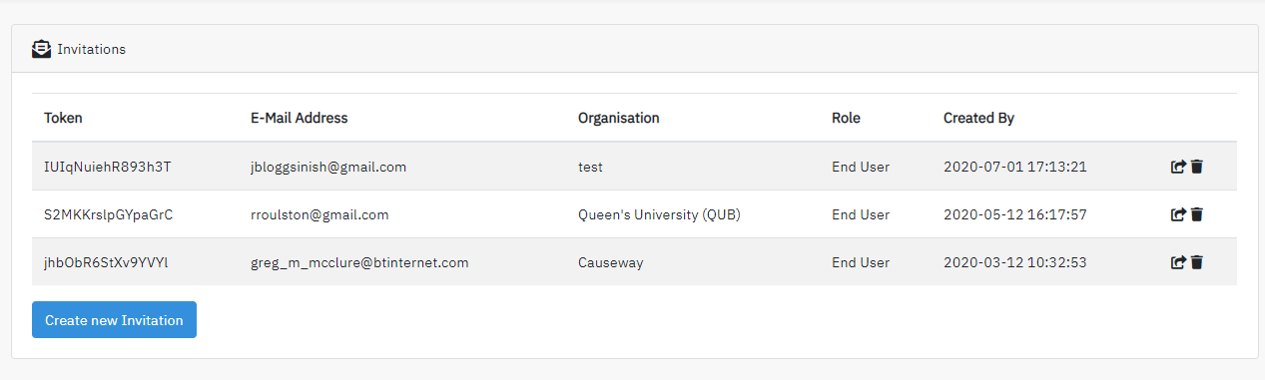

Click on the create new invitation button

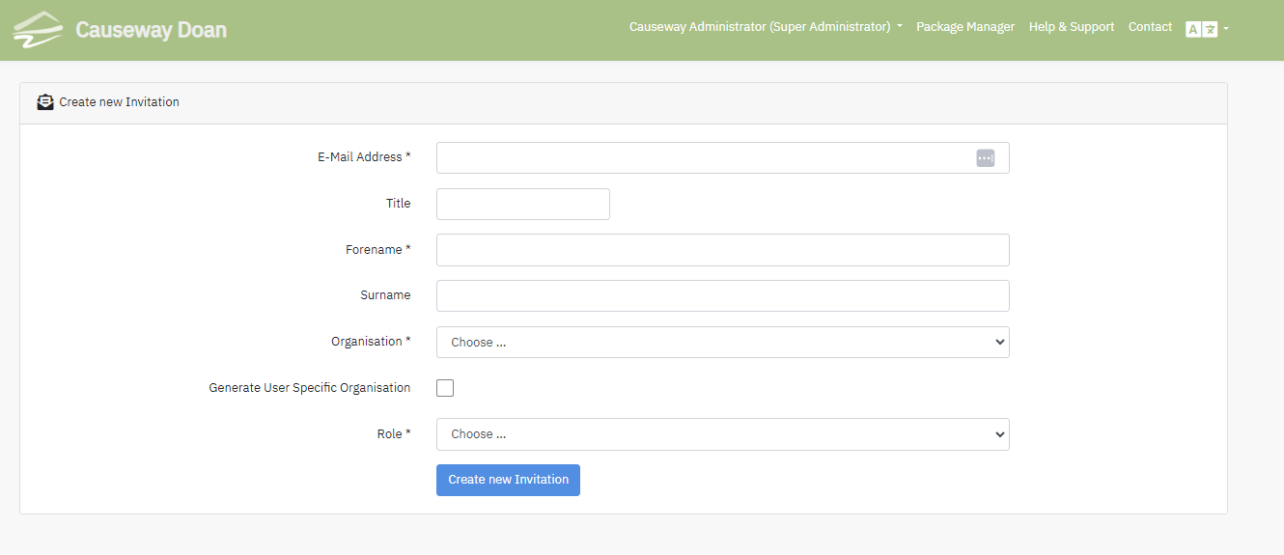
Input the email address of the author you want to invite, also insert their Title, Forename and Surname.

Select from the drop list the organisational unit to which the author should be attached.

Select the role of author.

Click Create new Invitation. An email is sent to the individual concerned.

This email contains a link to an online form that enables the new author to complete their personal details i.e. name and password. When they complete this task, the individual becomes a user(author) of the Causeway system.

Note: An invitation can be deleted if the individual has not completed the registration process.

User Management

When user management is selected a table of the users of the system in your institution is displayed.
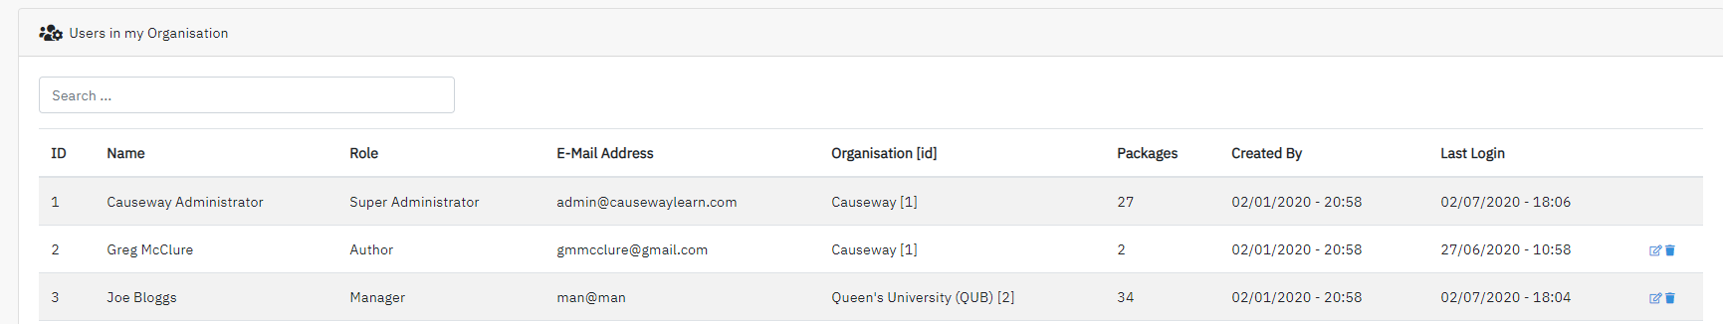

The display for each user contains: - user’s Title, Forename, Surname, role, email address, organisation unit, the number of packages created, the date the user account was created and their last login. The two icons on the left can be used to edit these details or delete the account

Edit: displays a screen for each user and the information can be edited and saved using the update user button. Also displayed is a summary of the user’s activity.

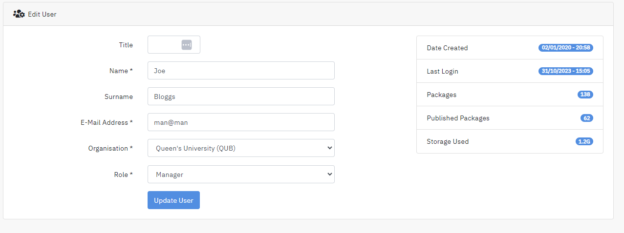

Currently Causeway is configured to allow up to 25 users, following negotiations this figure can be amended.

